**Report – Webpage Design**

Designer: Tszon Tseng

Justification from the previous design

As a down-to-earth webpage is designed to promote a well-known artist (Leslie Cheung) and his overwhelming influence on the public, it is better to include customer service in which fans or enthusiasts can make purchases on the periphery products about him. Take albums, CDs & DVDs, posters, and motion pictures for instance.

In this case, the web users can interact more proactively with the webpage and have a deeper browse throughout the website to consider what item is specifically more worth buying than others. On the buying page, an order form is implemented for customers to fill out their personal information and product details, which is similar to the interfaces that we commonly see on most online shopping platforms.

On top of that, the ameliorated website also comprises a fan page in which fans can have a look at several relevant links that conveniently direct them to different social media platforms, like Instagram and Facebook. They can feel free to exchange their valuable ideas and thoughts about a common topic in these suggested channels.

Validation

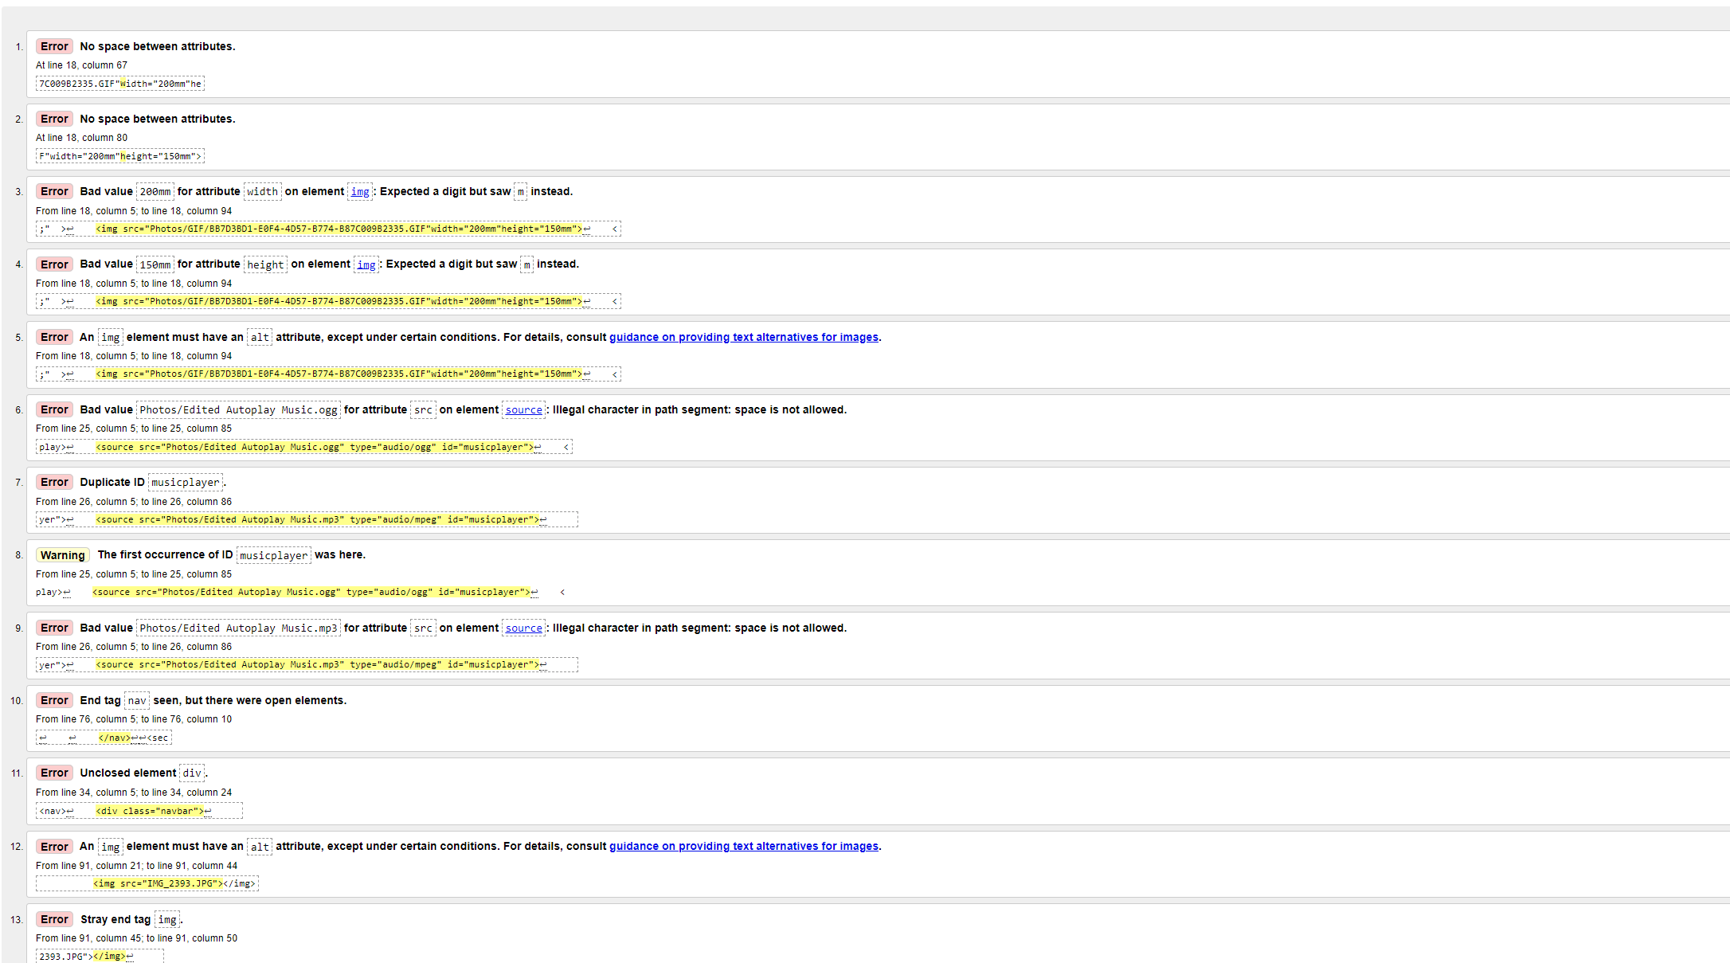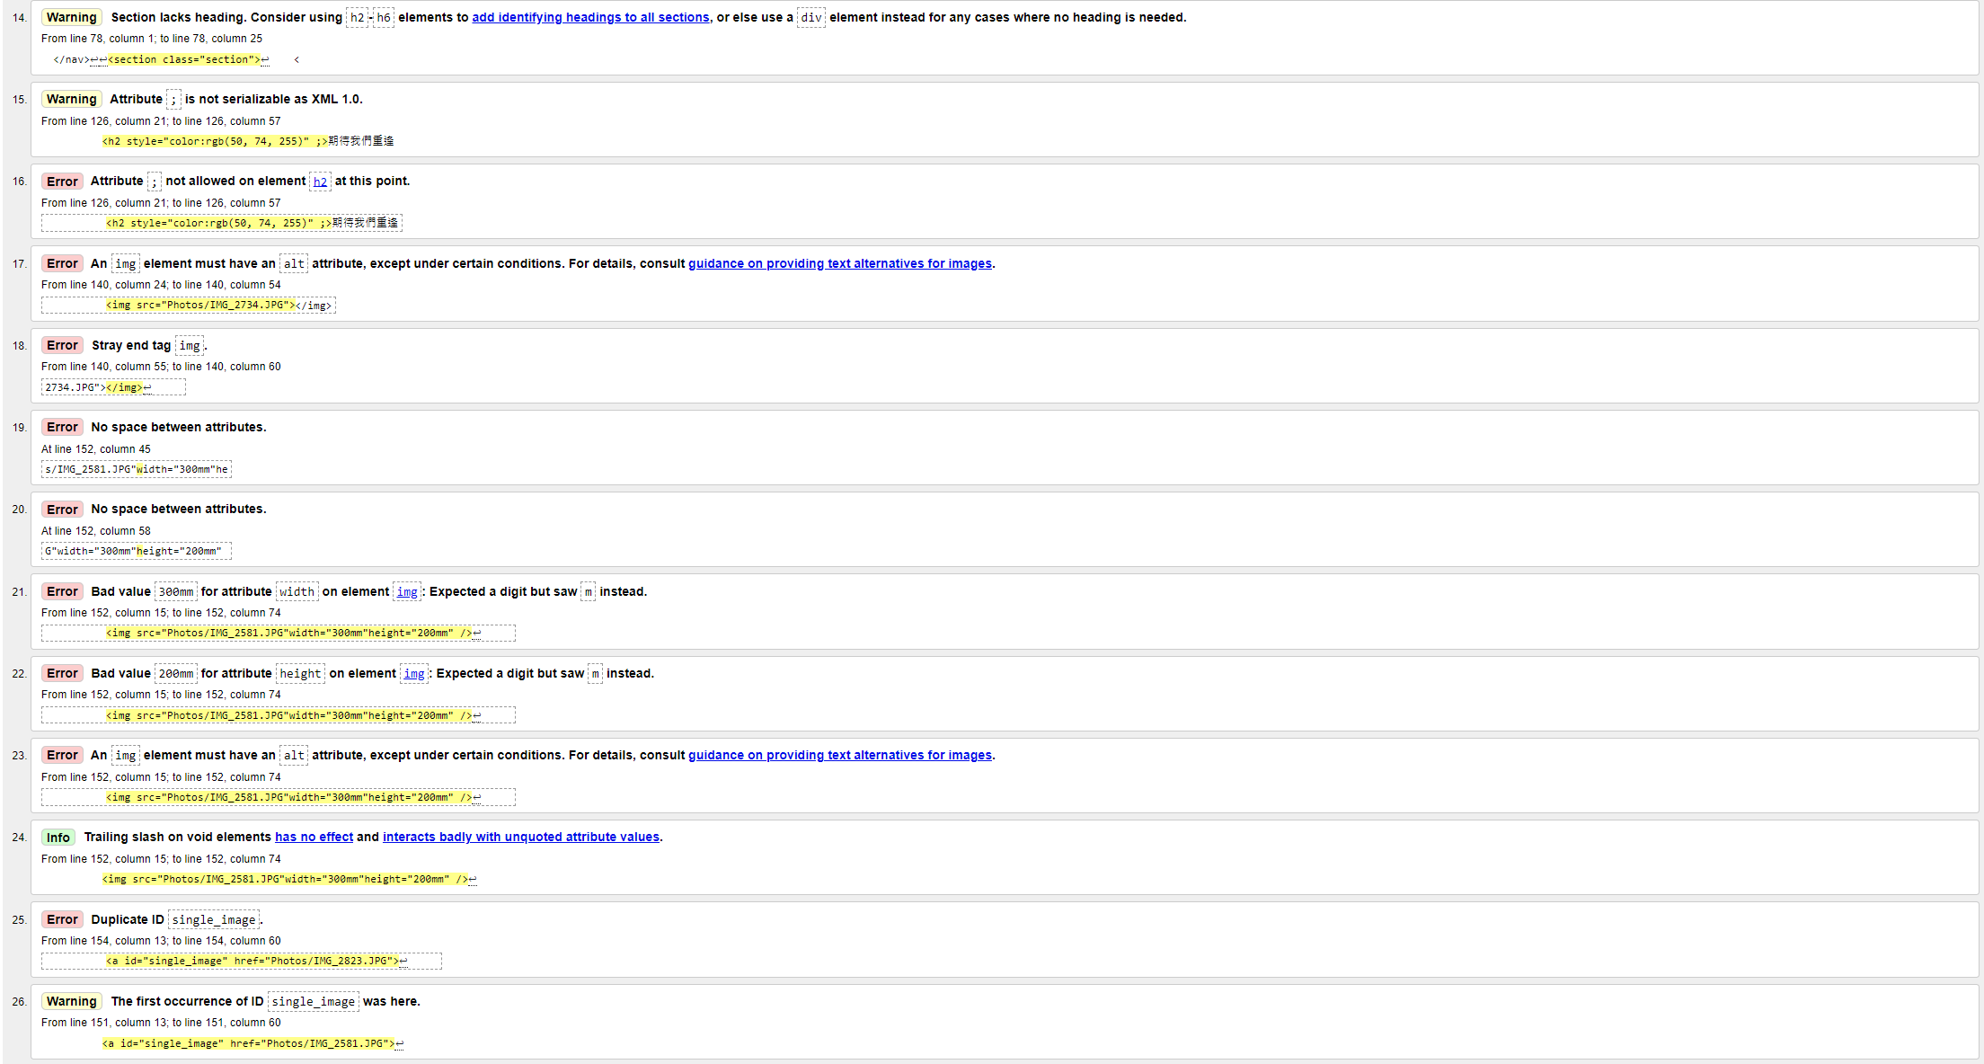

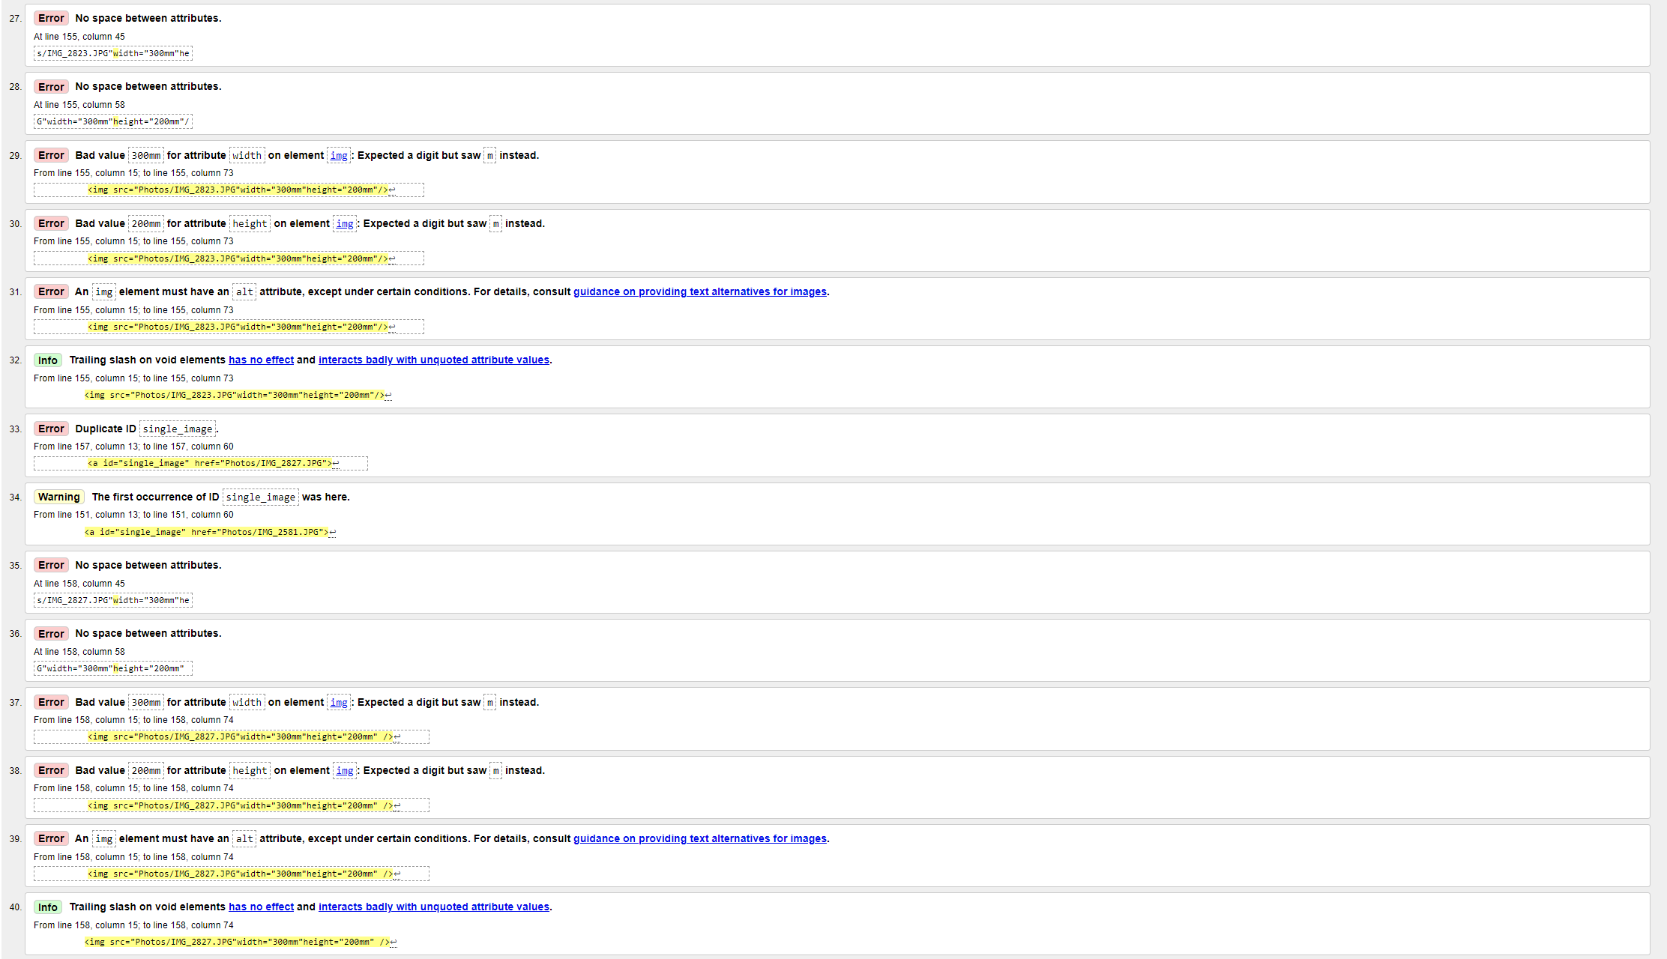

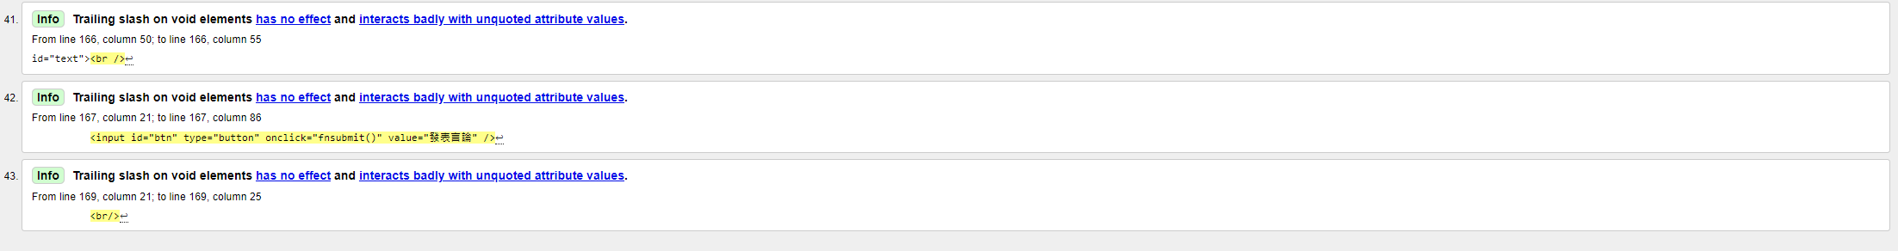

Testing Process

* Different Devices

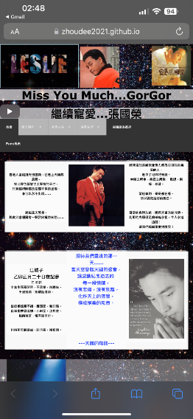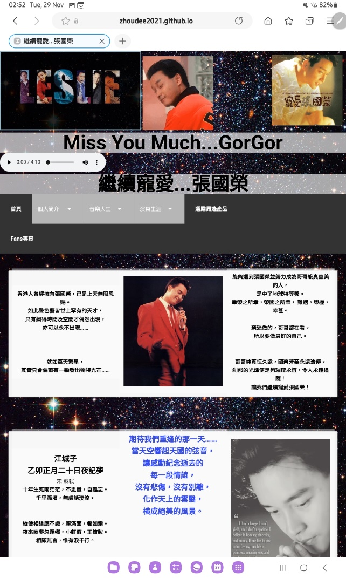

* The above three screenshots depict what the interface of the website looks like on Samsung Notebook (left), iPhone (right) and Desktop Computer (bottom). When it comes to different mobile devices, everything works fine for Desktop computers but one of the navigation bars accidentally sinks to the second row for IOS and Android. For all subpages of the website, the images and multimedia are displayed at a fairly readable scale and only a few of them are misplaced. In general, except for some subtle misplacements of words and images, the websites on different devices are more or less the same.
* Different Browsers

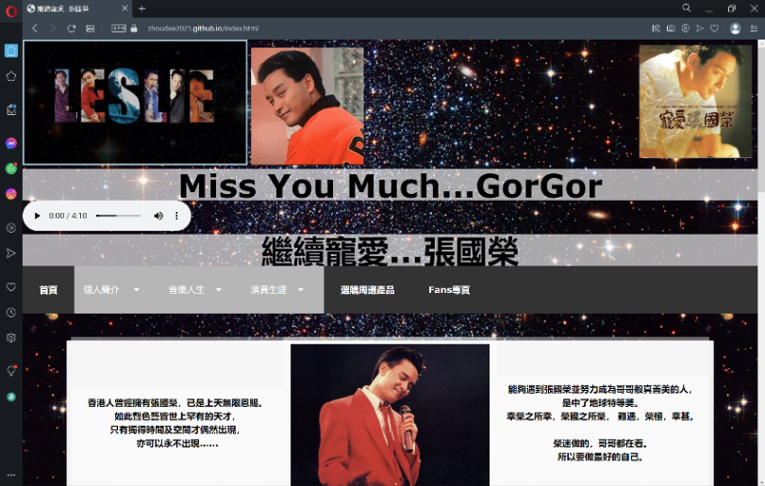(Opera Browser)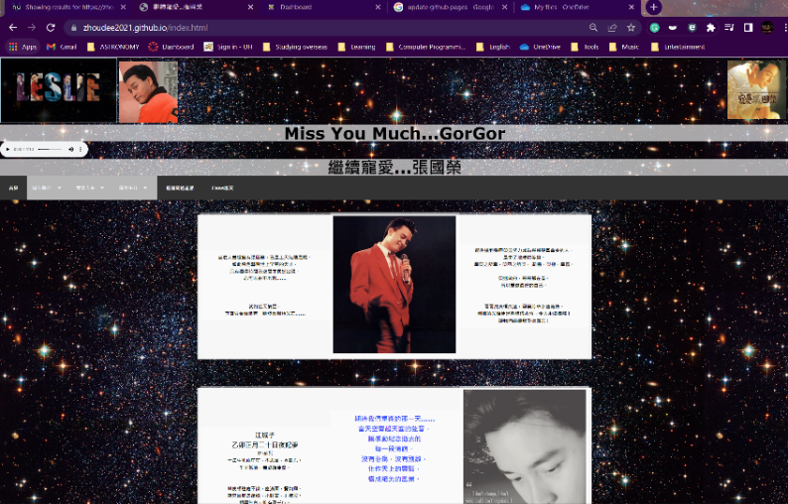(Google Chrome)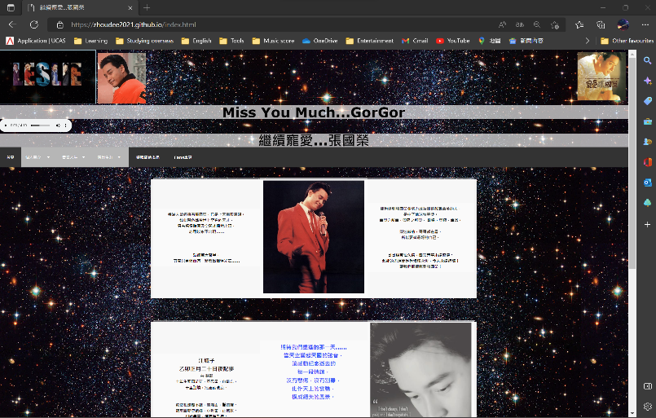(Microsoft Edge)

The above three screenshots depict how the interface of the website looks like on Opera Browser, Google Chrome and Microsoft Edge. Generally speaking, when it comes to various browsers, all of their displays look pretty much the same for Google Chrome and Microsoft Edge, but some of the words are unexpectedly bolder than others in Opera Browser.

* Accessibility and Usability

Overall, my website has adopted an intuitive design in which the architecture and navigation can be effortlessly understood by the users, enabling them to easily learn how to use it. Moreover, it gives subjective satisfaction towards the audience in which well-selected photos are included to help hold attention. Compared to other traditional informative websites, take Wikipedia as an example, it is unexpectedly lengthy and wordy in which users find it not worth investing time to browse through the website. This is where my inspiration comes from and enlightens me to have some extra multimedia to give more zest to the website, like adding audio sound effects and movable gifs. Visually speaking, I have made use of an eye-catching galaxy as my background of the page which hopefully aims to win audiences’ hearts to stay longer willingly so that they can have a more thorough browse of the website. In addition, adapting to the colour of the background, contrast colours should be implemented in the text to increase readability and user-friendliness. I have decided to add some transparent white paddings at the back of the text in the body so that web users can see easily and observe the contradictions between the text and background.

* Consistency

In terms of consistency, I have used consistently the same layouts for every single page on the website. Speaking of images, the icon (LESLIE) at the top-left-hand corner, a GIF in the top-middle position and a photo at the top-right-hand corner of the page. From the perspective of background and colour layout, the same background image and the padding of the same colour have been used repeatedly. To familiarise web users with the current website effortlessly, the visual setting should be applied as same as possible to eliminate any unnecessary illusions or confusion caused by the inconsistent layouts.

* Navigation

As was stated previously in consistency, the same display panels for navigation bars are adopted on every single page so that the web users can closely keep track of the website’s flow and thus redundant misunderstandings and perplexities are avoided. Visually speaking, whenever the users have their mouse pointers hovered over the navigation bars, the colours of the bars automatically changed to give clear signals to the users about what they are currently looking at. Speaking of functionality, for some of the navigation bars which involve sub-pages, such as ‘Music Life’, ‘Films’ and ‘Introduction’, a hidden list will be expanded out whenever the users have their mouse pointers hovered over the navigation bars. This delicate functionality indeed organises the users’ interface in an orderly manner by neatly contracting a messy array of links on the same webpage.

On top of that, a bunch of links are provided in the fan page session. Undoubtedly, for the sake of rendering clear and simple instructions to the users, these links are posted underneath whatever social media platforms are available. For instance, Facebook and Instagram are included as well as their corresponding icons which are extensively acknowledged by the general public. Web users find it effortless to be directed by all these sorts of links if they have any further interest in discovering Leslie Cheung’s deeds and accomplishments in any aspect.

Evaluation of the completed website

Honestly speaking, my design of the webpage is not impeccable enough and there is some room for improvement. First and foremost, the navigation bars are originally to be vertically expanded whenever the users have their mouse pointers hovered over the navigation bars, but instead, they are expanded horizontally which slightly shifts the whole row of navigation bars up and down. Second of all, the comment session at the bottom of every single page is considered to be too wide, which makes the users’ interface a bit messy and not that neat. If I were to implement a comment session on a website next time, some coding involving Javascript should be used instead to have a more elegant interface to be shown in front of the audience. These issues are not considered critical, but as a web designer, the users’ experience is all that matters no matter how insignificant and subtle the mistakes and imperfections are.

Critical evaluation of the development

In general, the outcome of the overall design is encouragingly satisfactory. In terms of visual graphics and elements, the users’ interface does look appealing to the audience. A background of a galaxy is used to present a dreamingly mysterious atmosphere in front of the users. Virtually, all the texts and images are shown on white paddings which makes it easier to look at on a relatively dark background. Additionally, supplementary images and icons are added whenever necessary to be more informative apart from just showcasing plain texts in rather a mundane and dull way. When it comes to the usage of multimedia, some well-selected mp3 music files are adjusted to be automatically played whenever the users are switching between pages. This approach hopefully is to hold the audience’s attention more and lure them to stay on the webpage to have a deeper and more thorough browse. The navigation bars do also play a significant role in preserving consistency throughout the entire webpage in which the audience can be given unconfusing guidance as well.

Speaking of functionality, there is pretty much of it to be a fan page. Having depicted some of the unskippable introductions of an artist which are considered to be of vital significance, disclosing the albums and motion pictures in which Leslie Cheung had been involved in producing, creating a purchasing page of all the periphery products relevant and some other friendly links to social media platforms.

Originally, the buying page has not been included in my blueprint. However, considering users’ perspectives and wanting the webpage to be sustainably updated, needless to say, this website has to be somehow profitable. This is probably thought to be one of the awesomeness of the webpage which stands out from others.

Despite some incompatible issues relating to the sizing of images and texts, this website works pretty well on some selected testing browsers and mobile devices. Nevertheless, some codings regarding different mobile devices should be included. to accomplish perfection.